Soupal Ghosh
Module 4 --- Test driven development and Logging framework .
Basic Junit :
Ecercise 3:
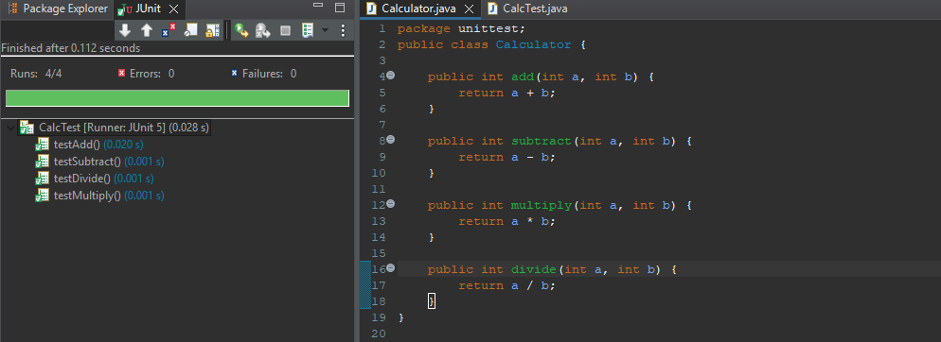
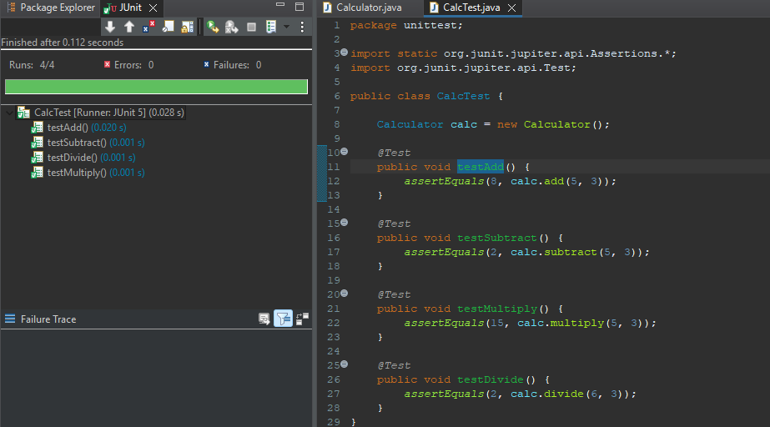
Exercise 4 :
package unittest;

import static org.junit.jupiter.api.Assertions.*;
import org.junit.jupiter.api.BeforeEach;
import org.junit.jupiter.api.AfterEach;
import org.junit.jupiter.api.Test;

public class CalcTest {

Calculator calc;

@BeforeEach
public void setUp() {
calc = new Calculator();
System.out.println("Setup executed");
}

@AfterEach
public void tearDown() {
System.out.println("Teardown executed");
}

@Test
public void testAddition() {

// Arrange
int a = 10;
int b = 20;

// Act
int result = calc.add(a, b);

// Assert
assertEquals(30, result);
}

@Test
public void testMultiplication() {

// Arrange
int a = 5;
int b = 4;

// Act
int result = calc.multiply(a, b);

// Assert
assertEquals(20, result);
}
}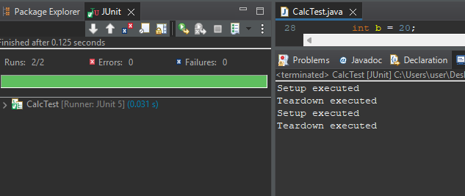
Advanced junit :
Exercise 1:
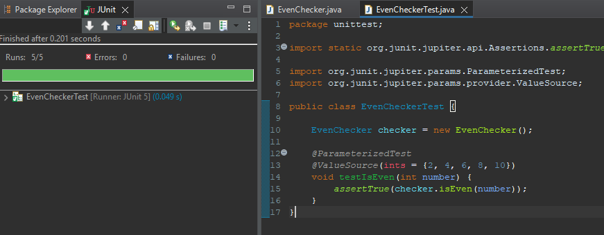
Exercise 2:
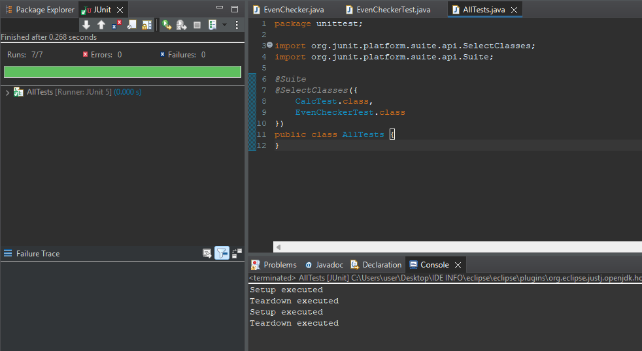
Exercise 3 :
Code :
package unittest;
import static org.junit.jupiter.api.Assertions.assertTrue;
import org.junit.jupiter.api.Order;
import org.junit.jupiter.api.Test;
import org.junit.jupiter.api.TestMethodOrder;
import org.junit.jupiter.api.MethodOrderer.OrderAnnotation;
@TestMethodOrder(OrderAnnotation.class)
public class OrderedTests {
@Test
@Order(1)
void testFirst() {
System.out.println("First Test");
assertTrue(true);
}

@Test
@Order(2)
void testSecond() {
System.out.println("Second Test");
assertTrue(true);
}
@Test
@Order(3)
void testThird() {
System.out.println("Third Test");
assertTrue(true);
}
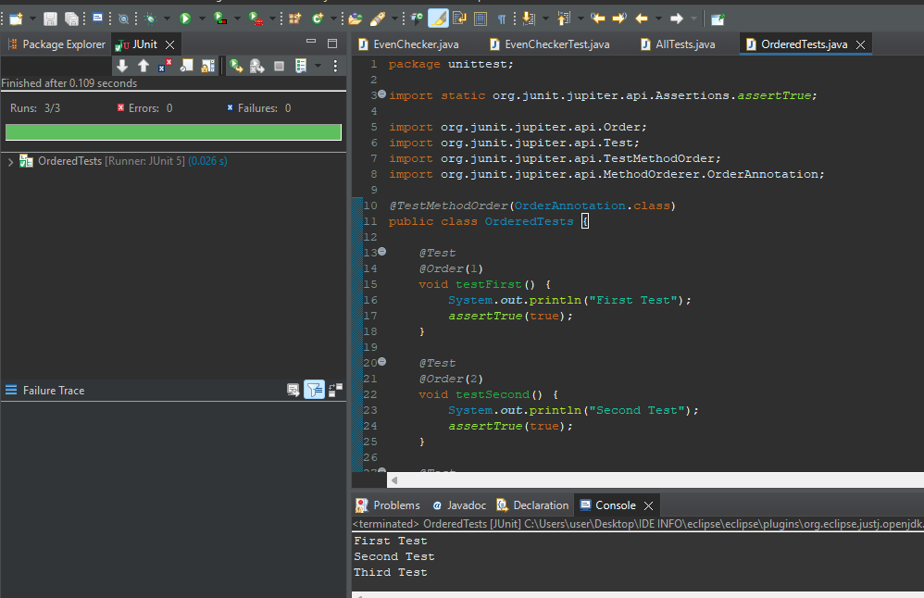
Exercise 4:
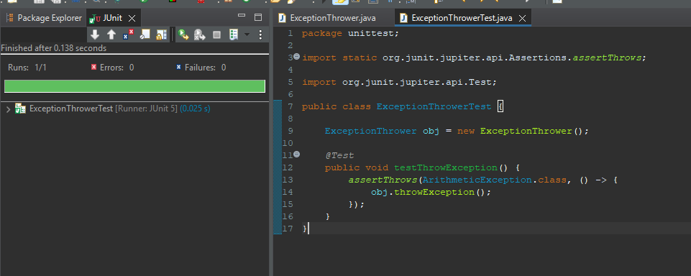
Exercise 5:
